Sales Automation

Step 1: Download Revise Punches report from RQ4

Step 2: Open Revise Punches Report then run

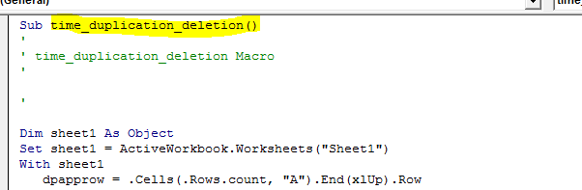

Step 3: Then run

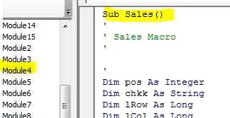

Note : Make sure Sales file has empty values in employee names and Bill Pay count, Acessories, etc

And file has located in the path or mention your path in coding

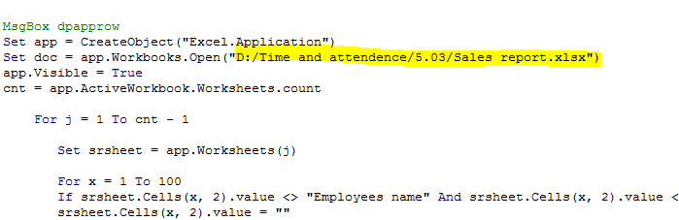

After Employee name result close time report excel and Sales report excel

Step 4: Open the Sales report file which has employee name updated list to run tio.xlsx and my perf.xlsx outputs report

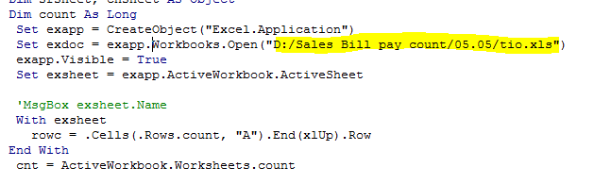

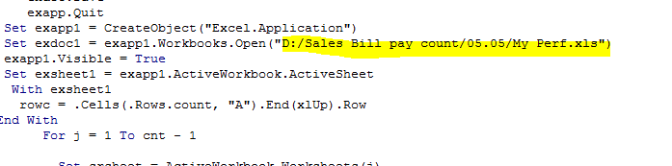

Make sure both files are present I location or mention the desired path

Step 5: Run macro from sales report.xlsx to get desired output